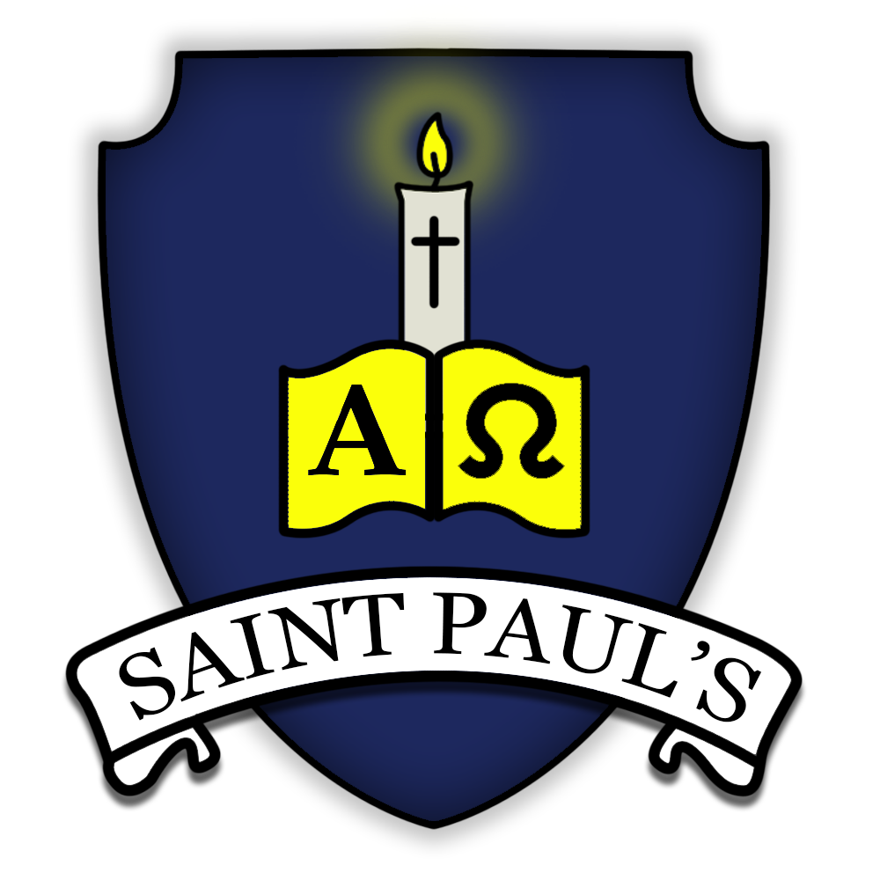
St Paul’s Catholic Primary School Subject: History Leader: Joshua Caves
Long term plan is below followed by the structure of each unit and then the knowledge organiser. Each unit has an assessment. Teachers should give it to the pupils cold at the beginning of the unit and then again at the end of the unit. The assessment will show what the pupils have learnt and what teachers need to recover in their next unit.
Our Vision:

At St Paul’s, we seek to provide pupils with the essential knowledge they need to be educated citizens in tomorrow’s world. It reflects our vision that every child will be supported to achieve their full potential, growing into the person God wants them to be and flourishing in His love.

Our curriculum is rooted in a rich knowledge and understanding of our history and heritage, our culture and community and our local challenges and opportunities. Our intent is to make a real difference to children’s lives, raising their own and others’ aspirations, securing educational success and deepening their knowledge and love of self and others around them.

We seek to develop our children’s awe and wonder, their self confidence and their ability to be an ‘agent of change’. We want our children to know their world, to keep themselves safe and healthy, to live economically, to ‘set the world on fire’.

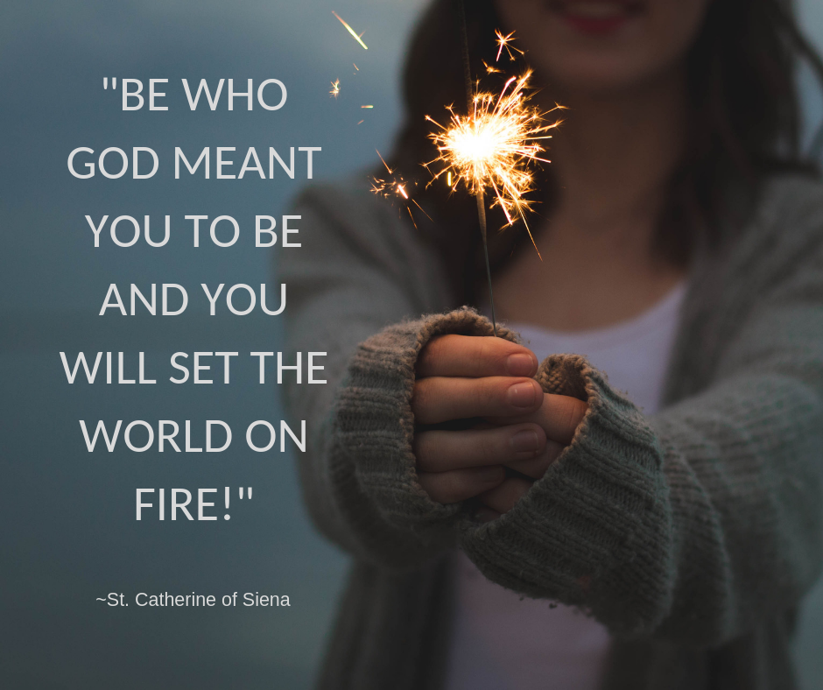

The intent of our History Curriculum at St Paul’s

Our high-quality History education at St Paul’s aims to inspire pupils’ curiosity to know more about the past, developing a knowledge and understanding of Britain’s past and that of the wider world. Pupils should develop key skills including asking perceptive questions, thinking critically, weighing up evidence, sifting arguments and developing perspective and judgement.`

The aims for implementation of our curriculum for History at St Paul’s

To ensure that all pupils:
- Know and understand history as a coherent, chronological narrative, from the earliest times to the present day: how people’s lives have changed the nation and how Britain has influenced and been influenced by the wider world.
- Know and understand significant aspect of history of the wider world: the nature of ancient civilisations; the expansion and dissolution of empires; characteristic features of past non-European societies; achievements and follies of mankind.
- Gain and deploy a historically grounded understanding of abstract terms such as ‘empire’, ‘civilisation’, ‘parliament’ and ‘peasantry’.
- Understand historical concepts such as continuity and change, cause and consequence, similarity and difference and use them to make connections, draw contrasts, analyse trends, pose historically-valid questions and create their own structured accounts, including written accounts and analyses.
- Understand the methods of historical enquiry, including how evidence is used rigorously to make historical claims, and discern how and why contrasting arguments and interpretations of the past have been constructed.
- Gain historical perspective by placing their growing knowledge into different contexts, understanding the connections between local, regional, national and international history; between cultural, economic, military, political, religious and social history; and between short-term and long-term timescales.
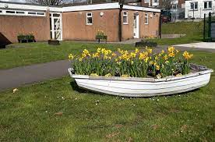
Reception Year (EYFS)

During the Early Years Foundation Stage children will develop their historical understanding throughout the year as part of story-based projects. A large emphasis is placed upon developing children’s vocabulary through texts and first-hand experiences. This will begin with exploring the concept of the past using recent events from their own lives e.g. when they visited school on transition visits. As the year progresses children will investigate changes, figures and events beyond their own lifetime. They will be able to explore a range of historical artefacts, use a variety of texts and visit a museum to develop their understanding of the past. This will provide opportunities to discuss how familiar things have changed over time e.g. transport, household objects in a range of contexts in relation to both core stories and the children’s own interests. The development of these enquiry skills will prepare children for learning about key historical changes, figures and events as they progress onto the National Curriculum in Year 1.

Early Years Foundation Stage Framework (2021)
Educational Programmes: Understanding the World
Understanding the world involves guiding children to make sense of their physical world and their community. The frequency and range of children’s personal
experiences increases their knowledge and sense of the world around them – from visiting parks, libraries and museums to meeting important members of
society such as police officers, nurses and firefighters. In addition, listening to a broad selection of stories, non-fiction, rhymes and poems will foster their
understanding of our culturally, socially, technologically and ecologically diverse world. As well as building important knowledge, this extends their familiarity
with words that support understanding across domains. Enriching and widening children’s vocabulary will support later reading comprehension.

ELG: Past and Present
Children at the expected level of development will: - Talk about the lives of the people around them and their roles in society; - Know some similarities and
differences between things in the past and now, drawing on their experiences and what has been read in class; - Understand the past through settings,
characters and events encountered in books read in class and storytelling

Year group/Term | Autumn term | Spring term | Summer term
Reception |  | Peek into the past | adventures over time
Year 1 | How am I making History? | How have toys changed? | How did we learn to fly?
Year 2 | What is History? | How was school different in the past? | What is a monarch?
Year 3/4 | Would you prefer to live in the Stone age or the Iron age? | Why did the Romans settle in Britain? | How hard was it to invade and settle in Britain?
Year 4/5 | How have children’s lives changed? | What did the ancient Egyptians believe? | How did the society of the ancient Mayans impact their society and beyond?
Year 6 | How did the society of the ancient Mayans impact their society and beyond? | What was the impact of World War II on the people of Britain? | What does the census tell us about our local area?

Reception - Peek into the past

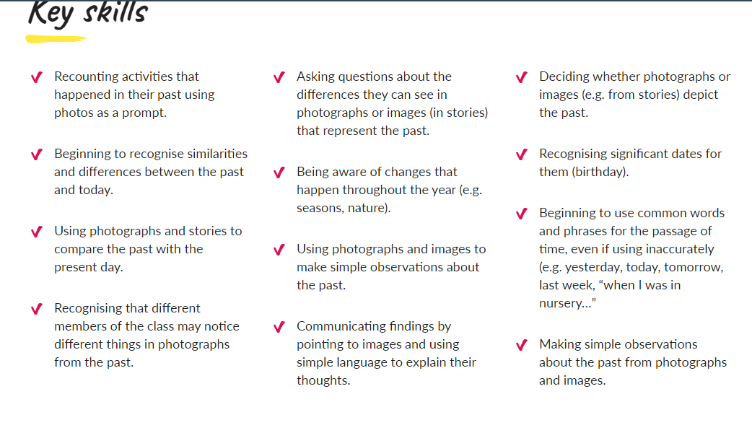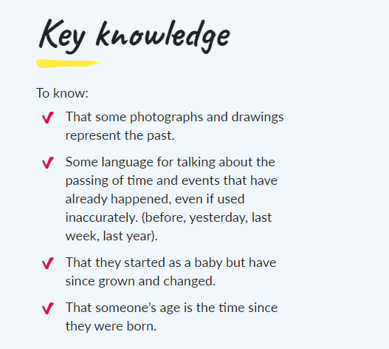

Reception - Adventures through time

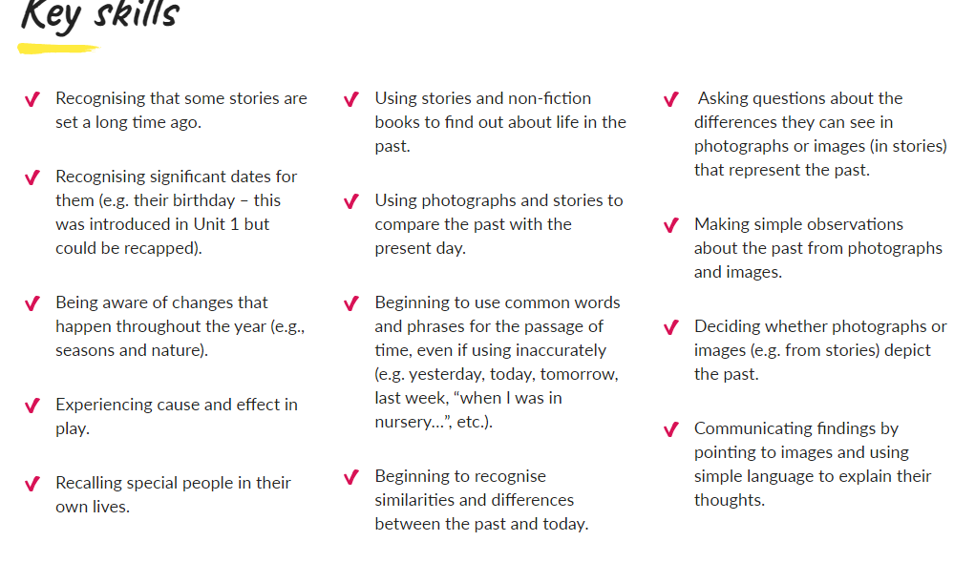

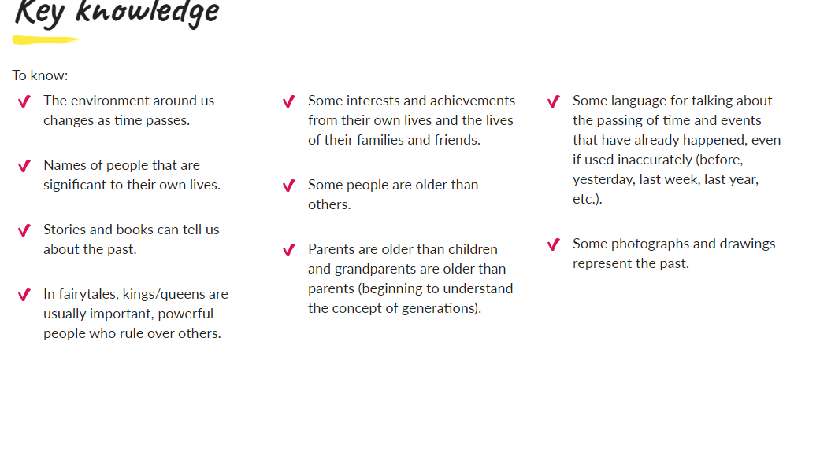

Year 1
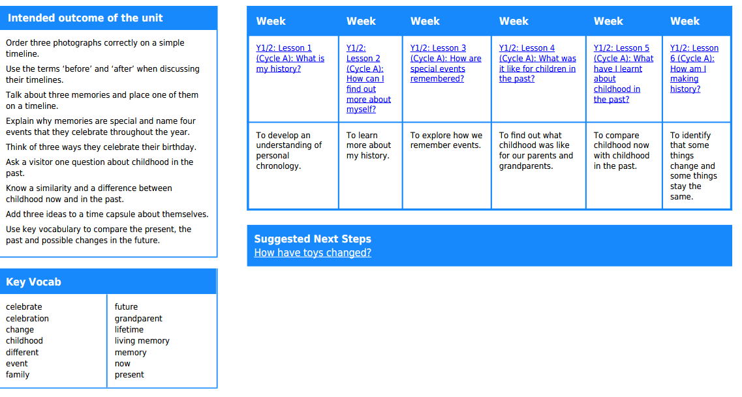

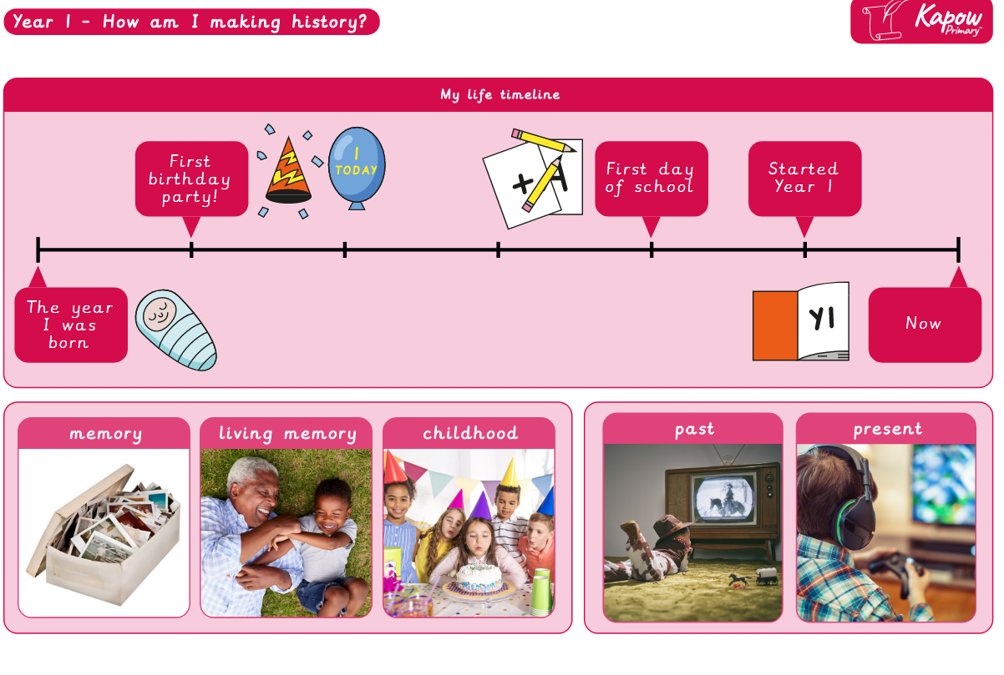

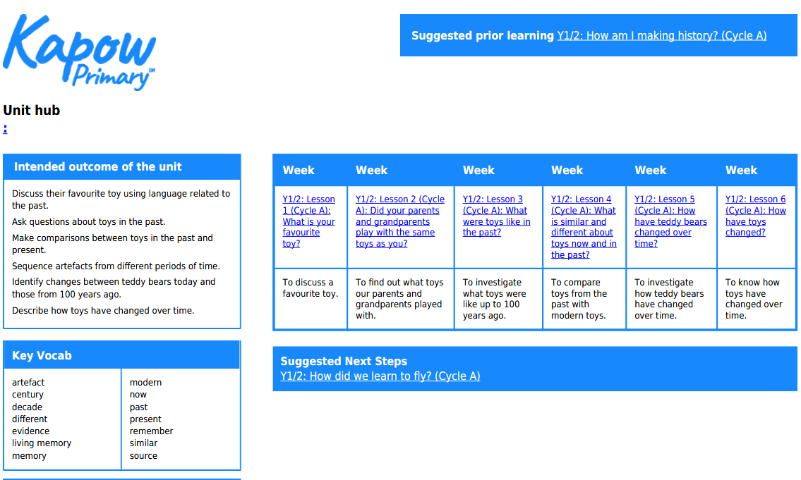
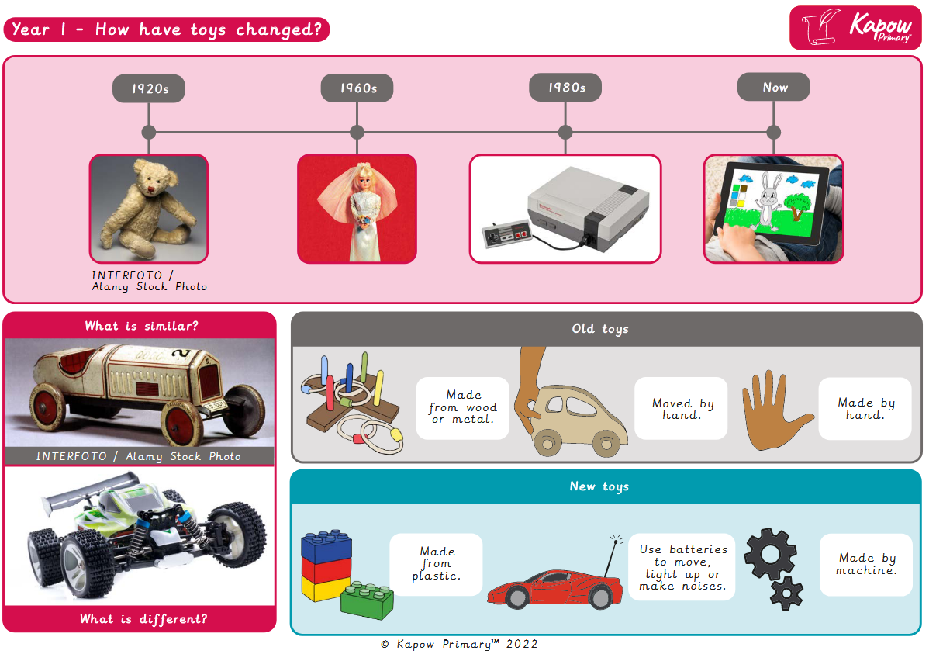
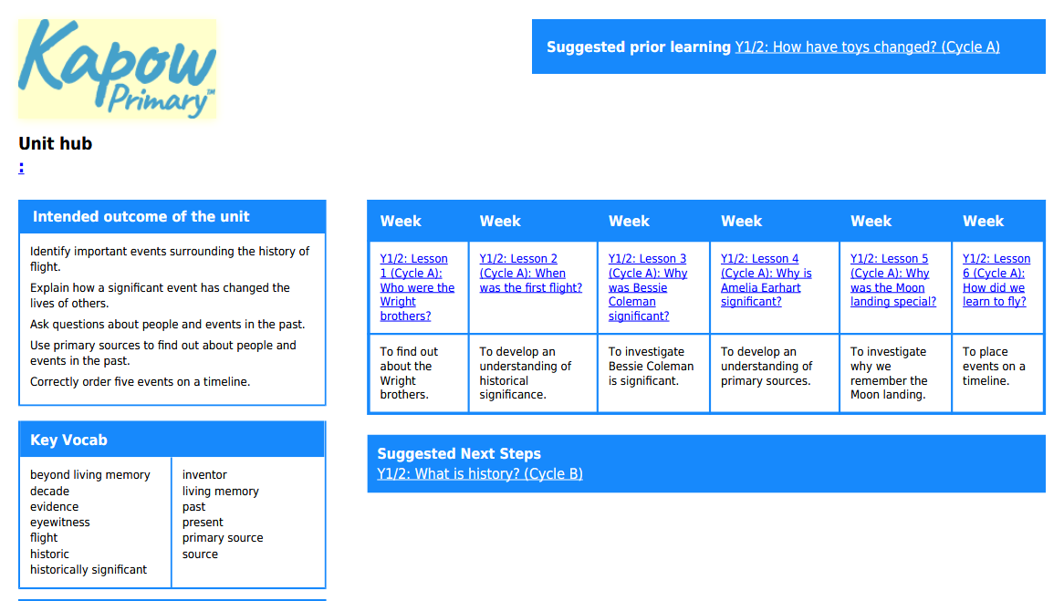

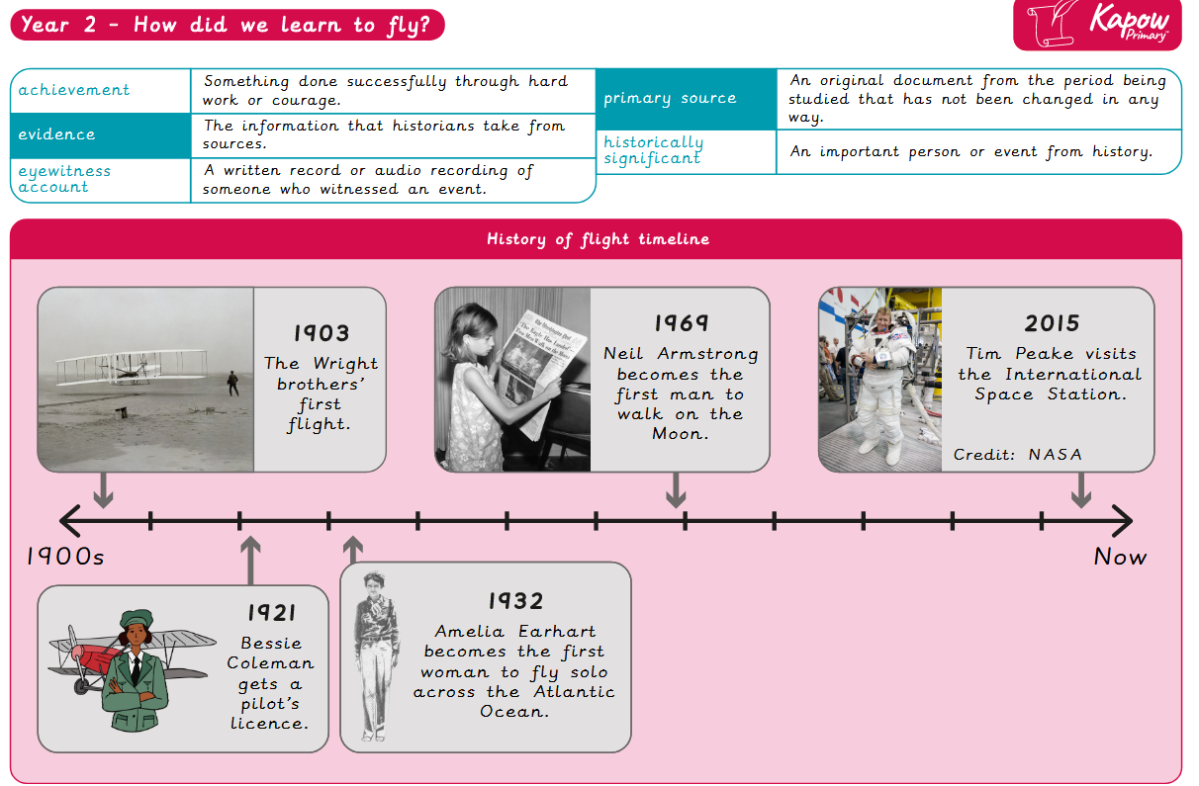
Year 2
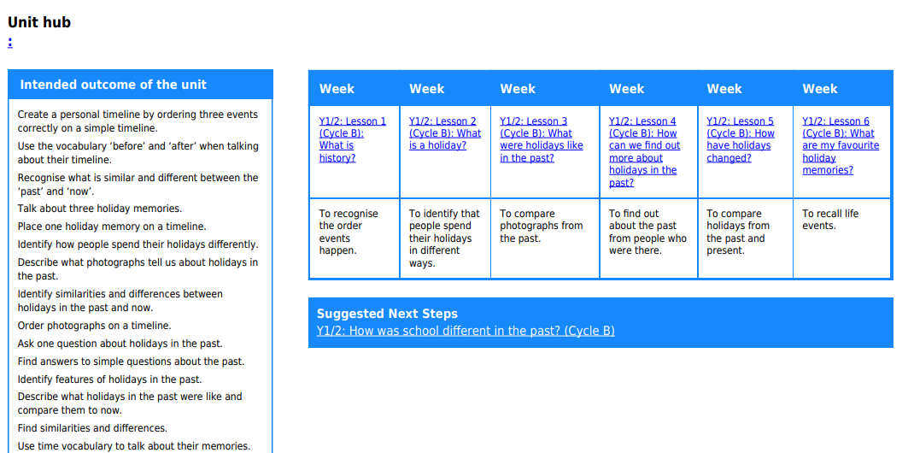

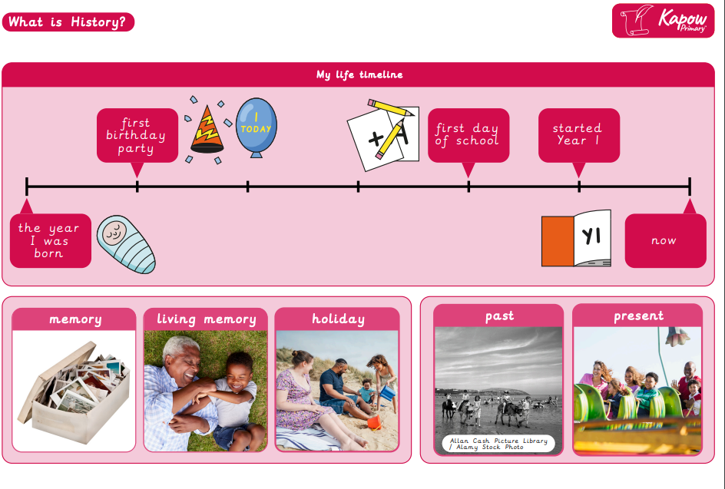
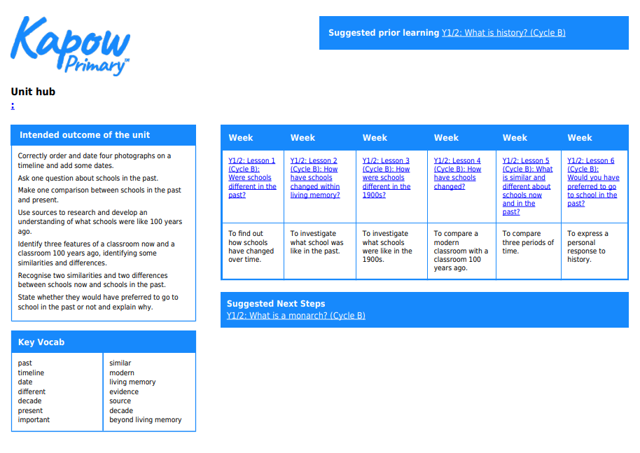

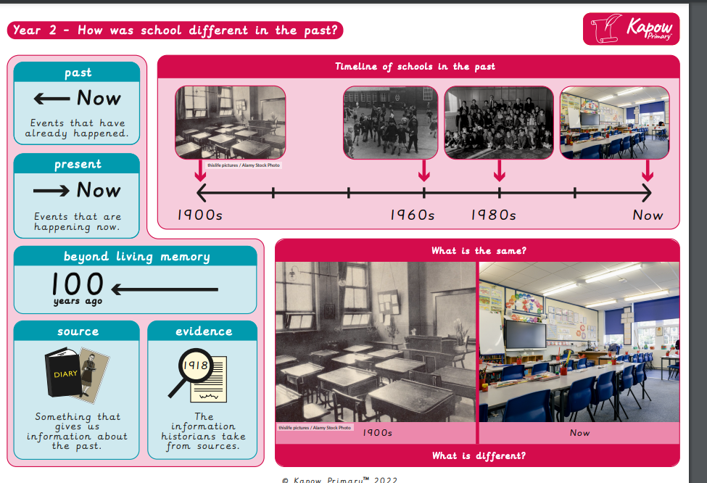
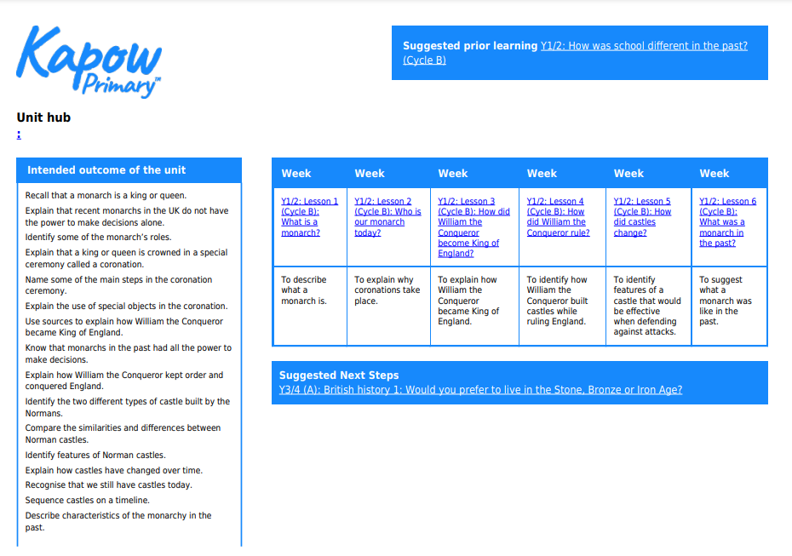

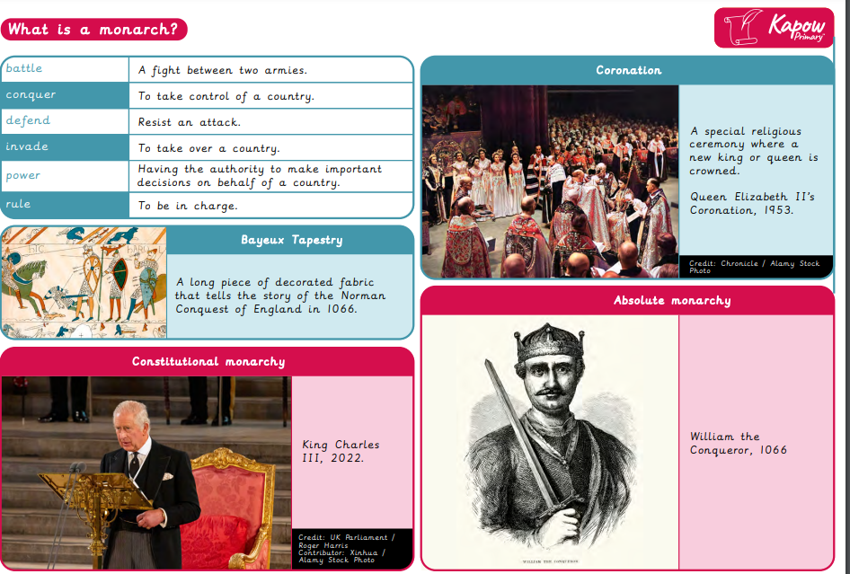

Year 3/4
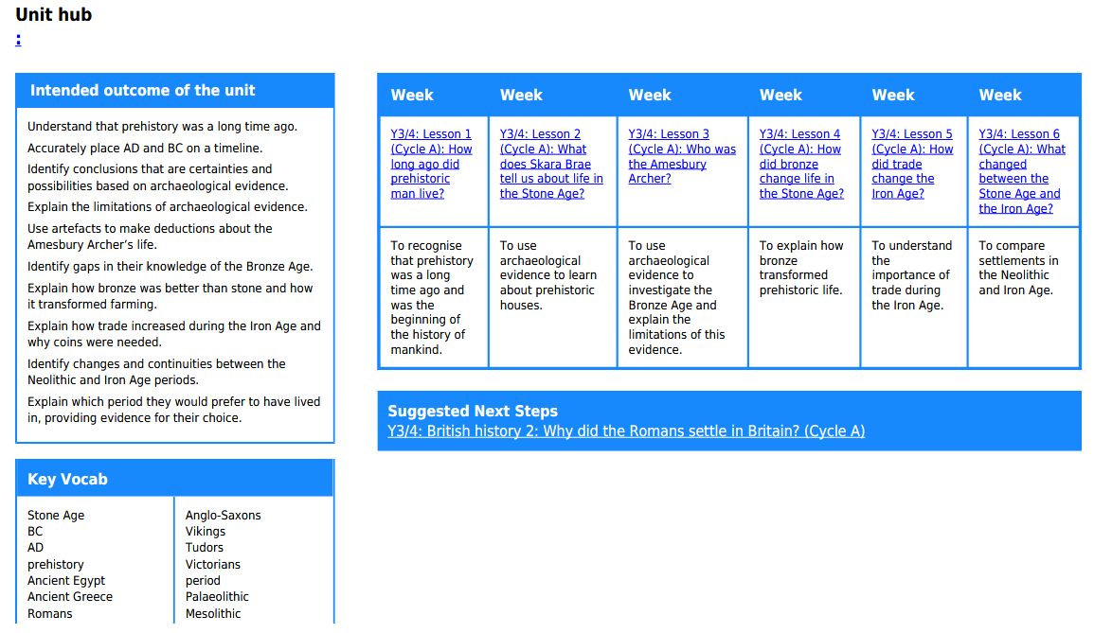

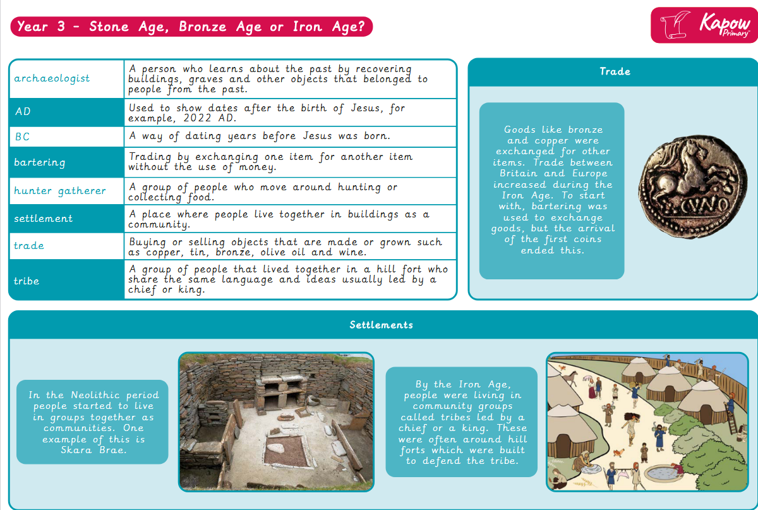

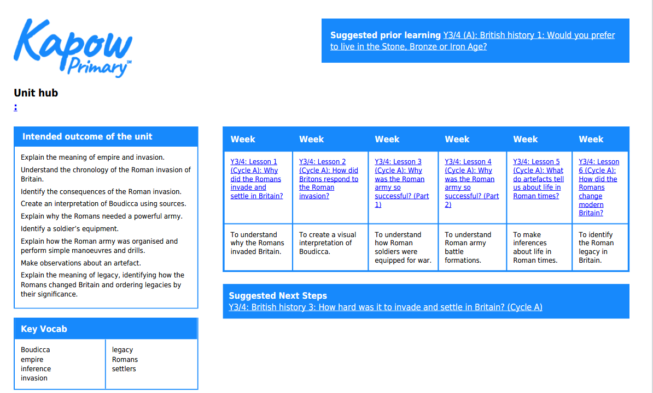

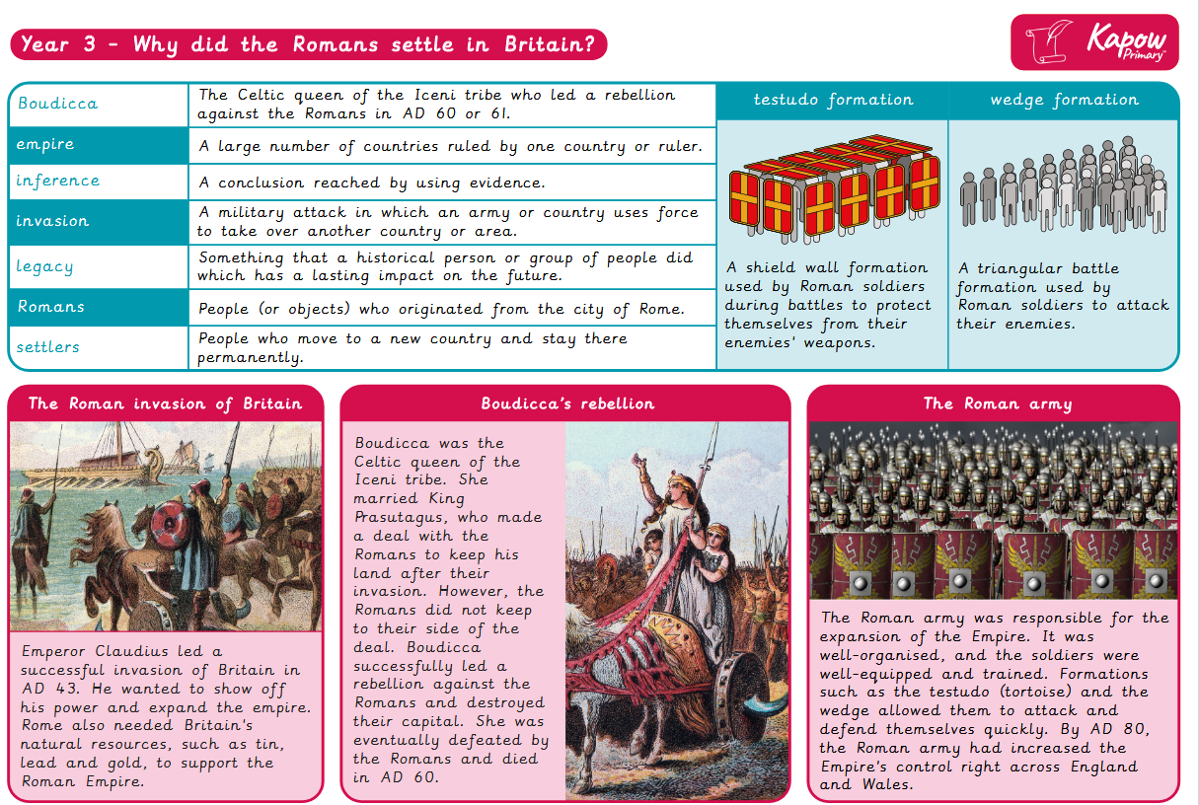

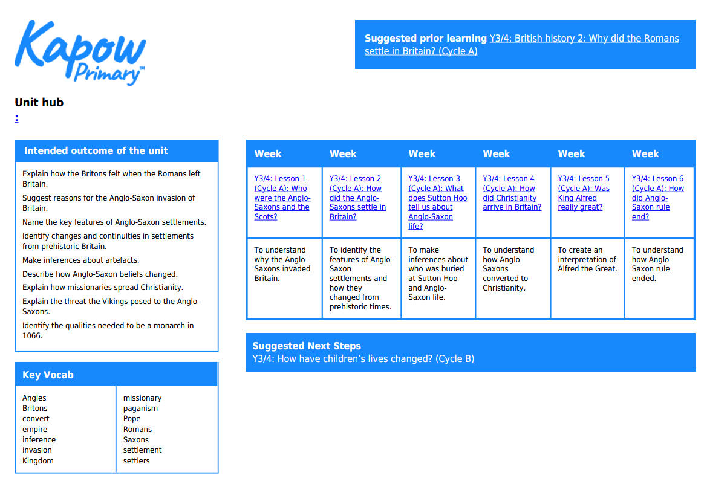
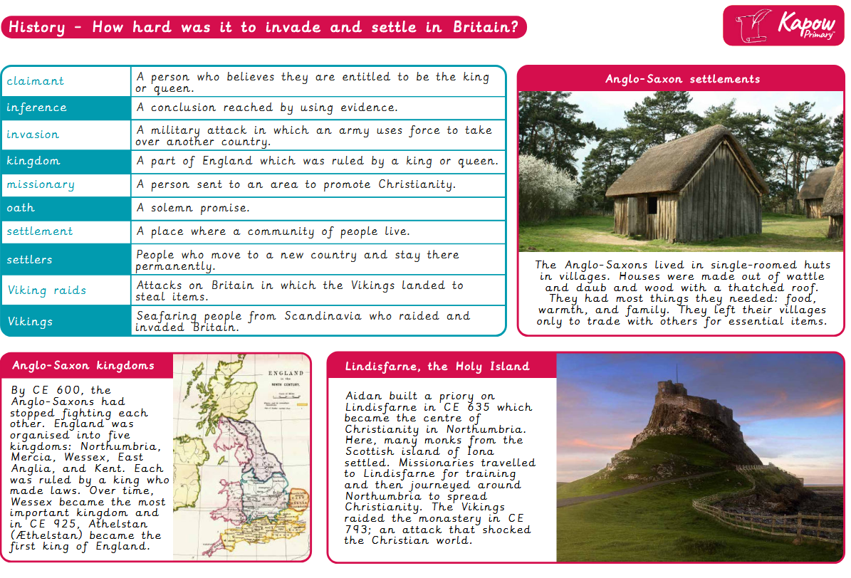
Year 4/5
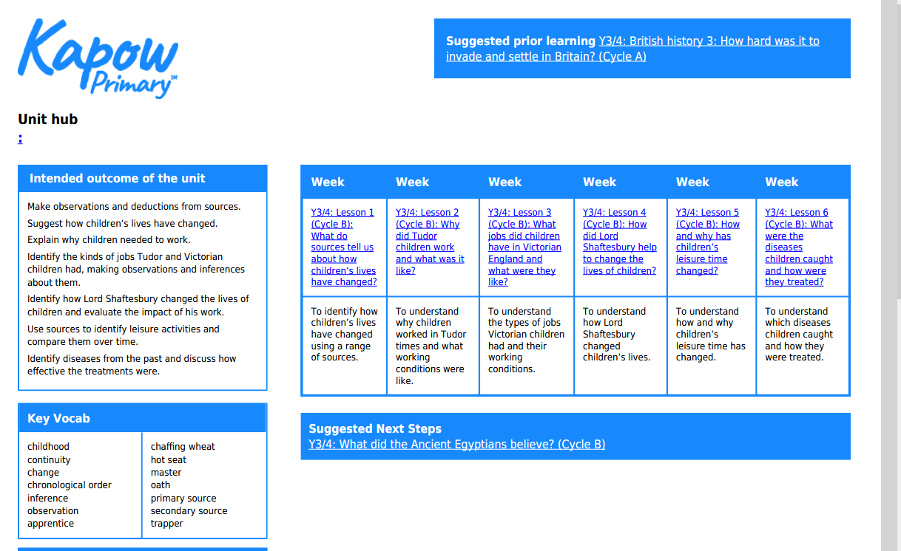
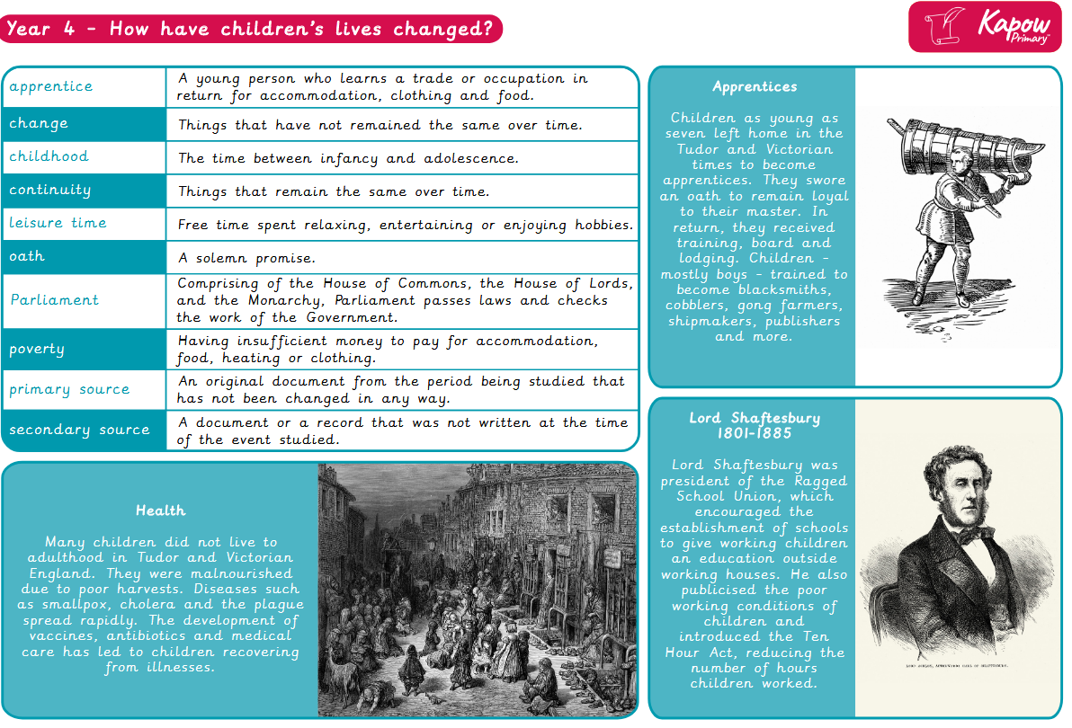
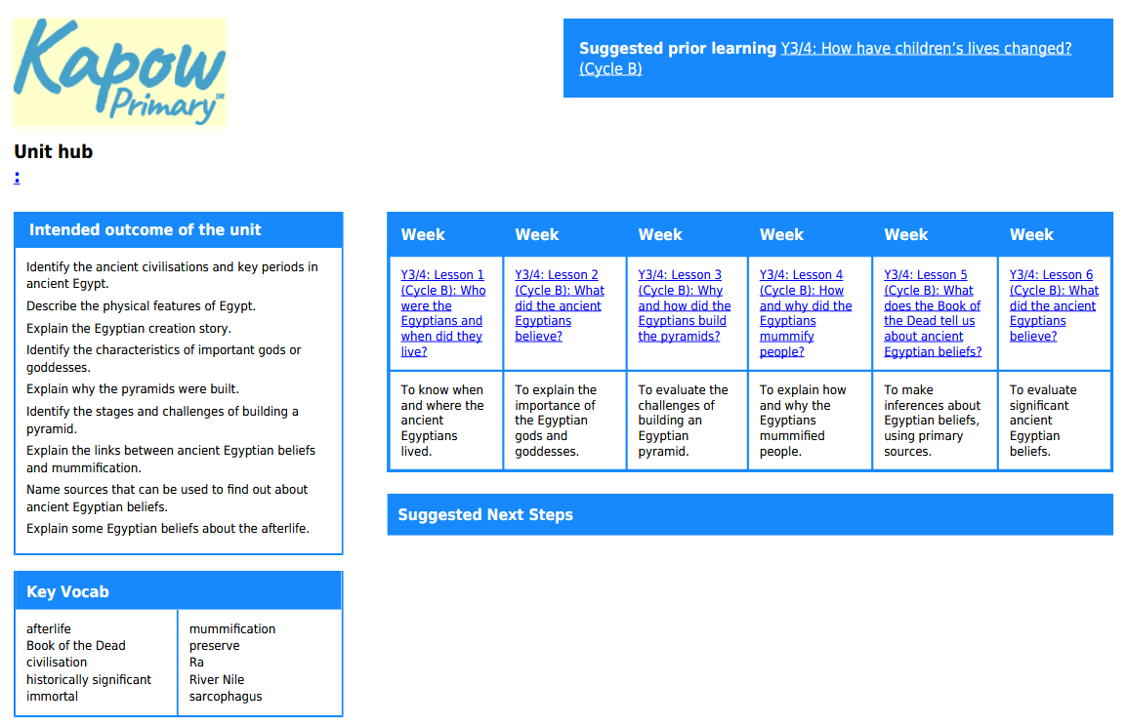
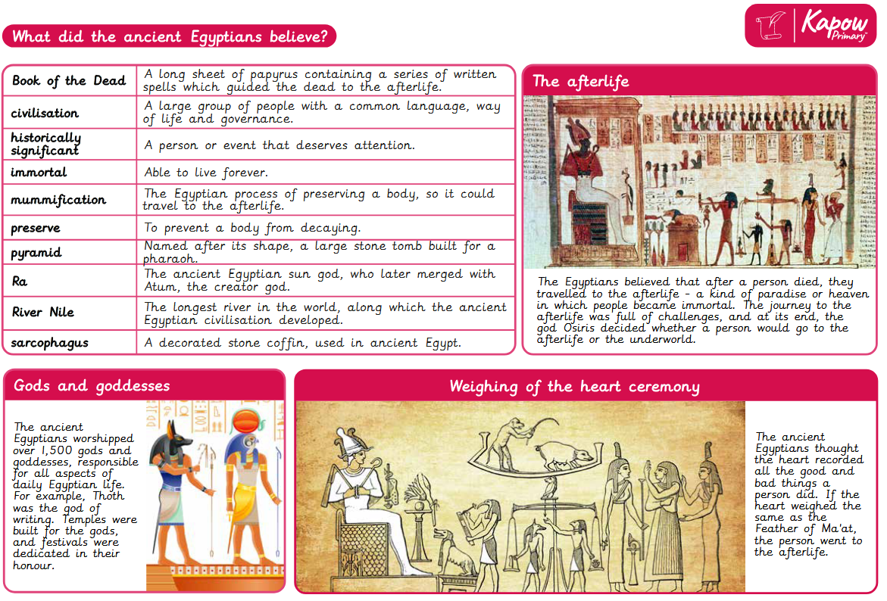
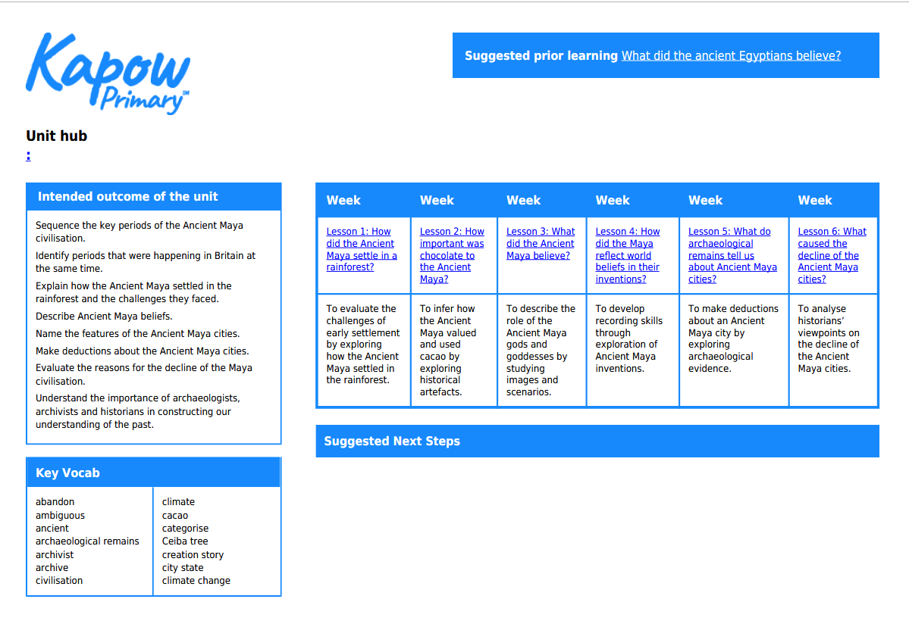
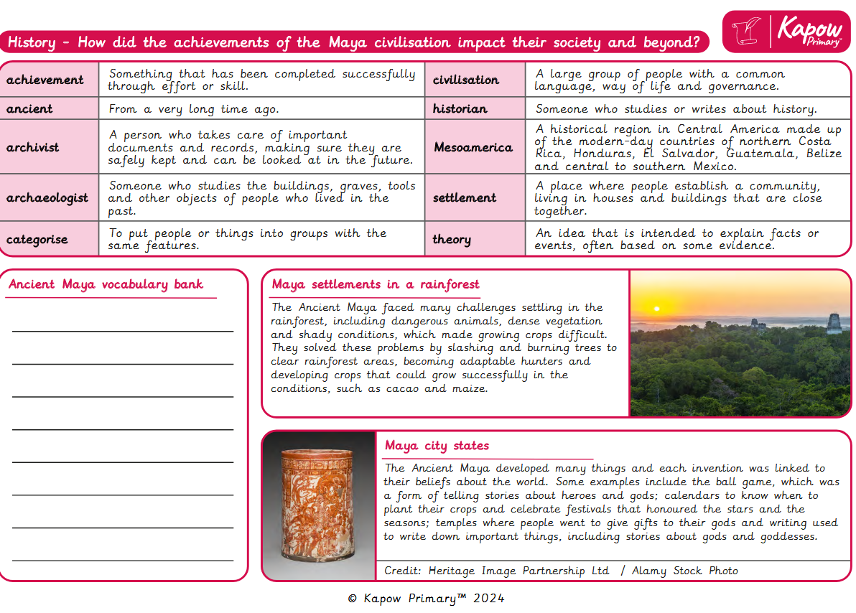
Year 6

